Your starting point here is the completed version of Exercise 6.2. If you already closed that file, please reopen it using the Power BI software. You should first complete the previous exercises before starting with this one. If you just wrapped up the last assignment, your view would probably look like the image below.

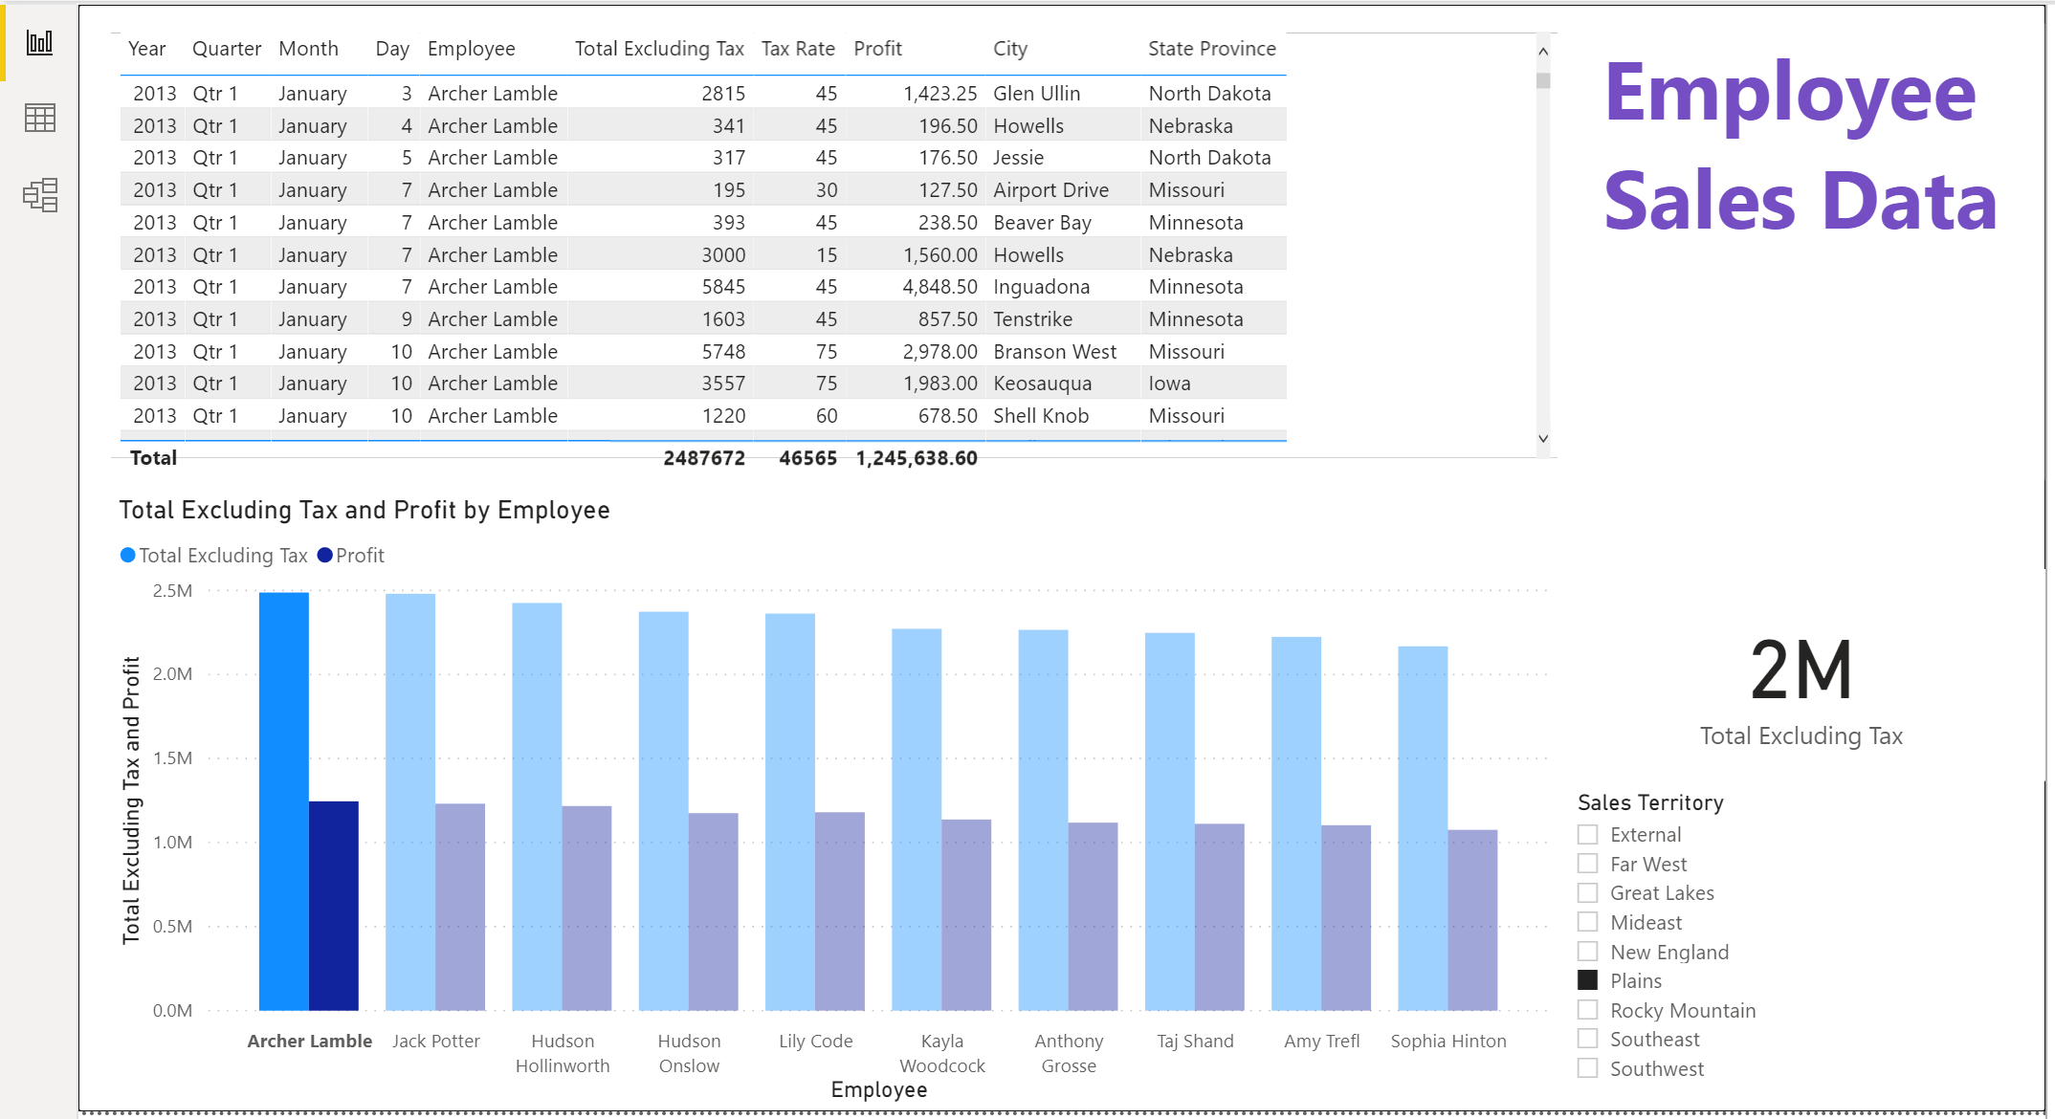

Load the dimension table called “DimStockItem.csv”: Home > Get data > Text/CSV > find DimStockItem.csv > Open > Transform Data

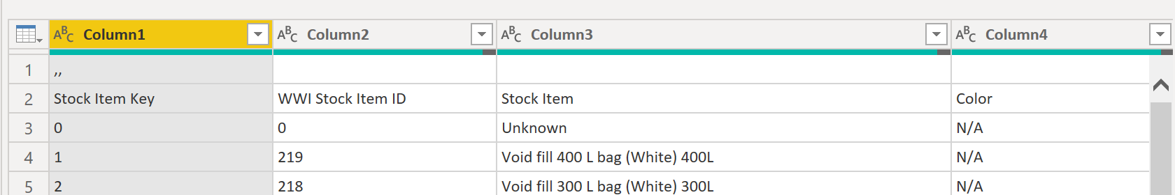

As you can see, this table is not clean. So, apply some cleansing techniques including the removal of row 1. You already know how to do this in the previous exercise.

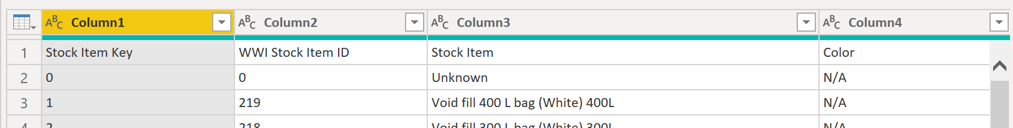

Then, use the first row as the header. You also know how to do this from the previous assignment.

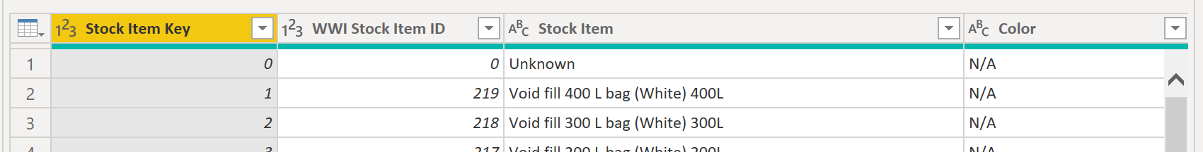

The first row is gobbledygook, so remove it.

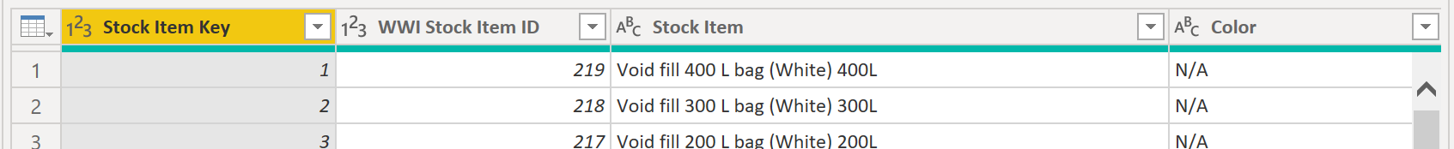

Now, this table is scrubbed. So, Close & Apply the changes.

This will save your new table in the data model. Switch to Model view. Observe how Power BI automatically wired the DimStockItem master file to the FactSale transaction table through their common field Stock Item Key.

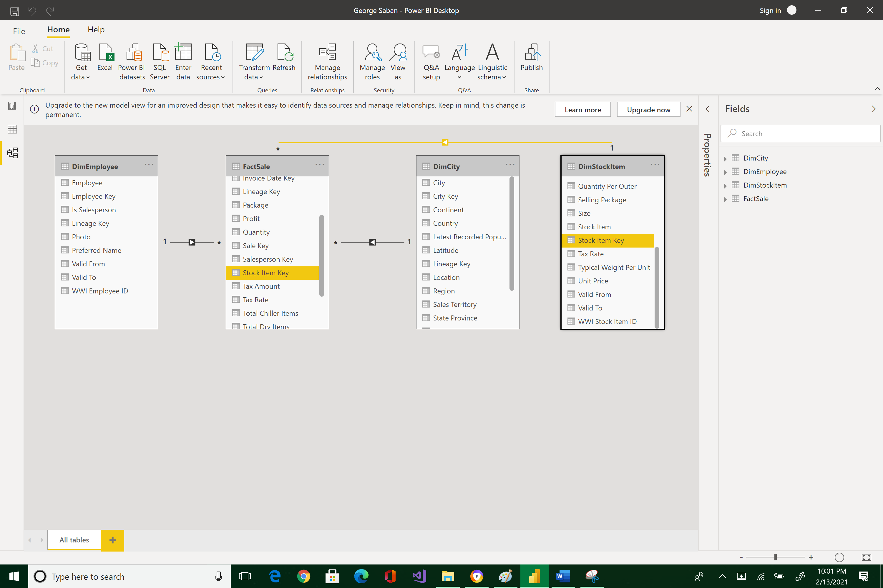

Switch to Report view. Add a new visual page by clicking on the plus (+) symbol at the bottom.





Page 1 will be created.



Make a visualization for the color of the item and its unit price by clicking on the Color field of the DimStockItem table.

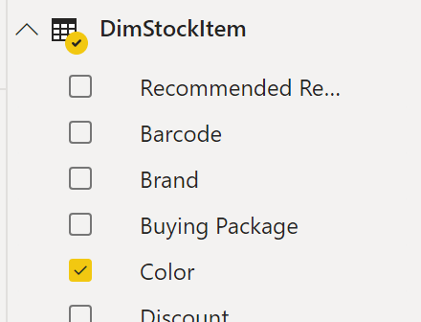 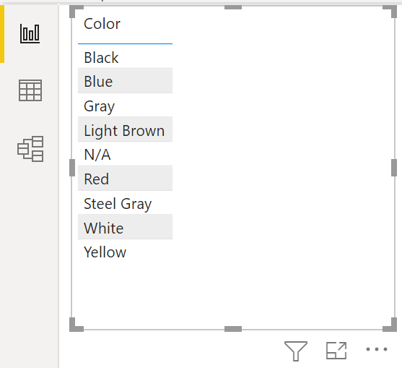



Click also the Unit Price field in the FactSale table.

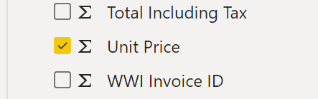 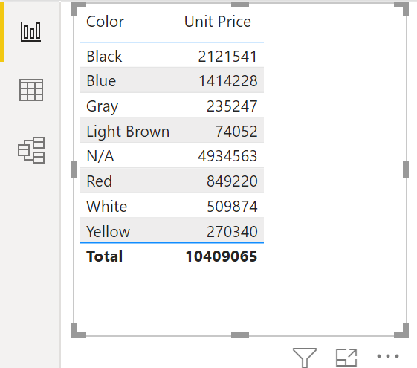



Use the Clustered bar chart to visually render these two values.

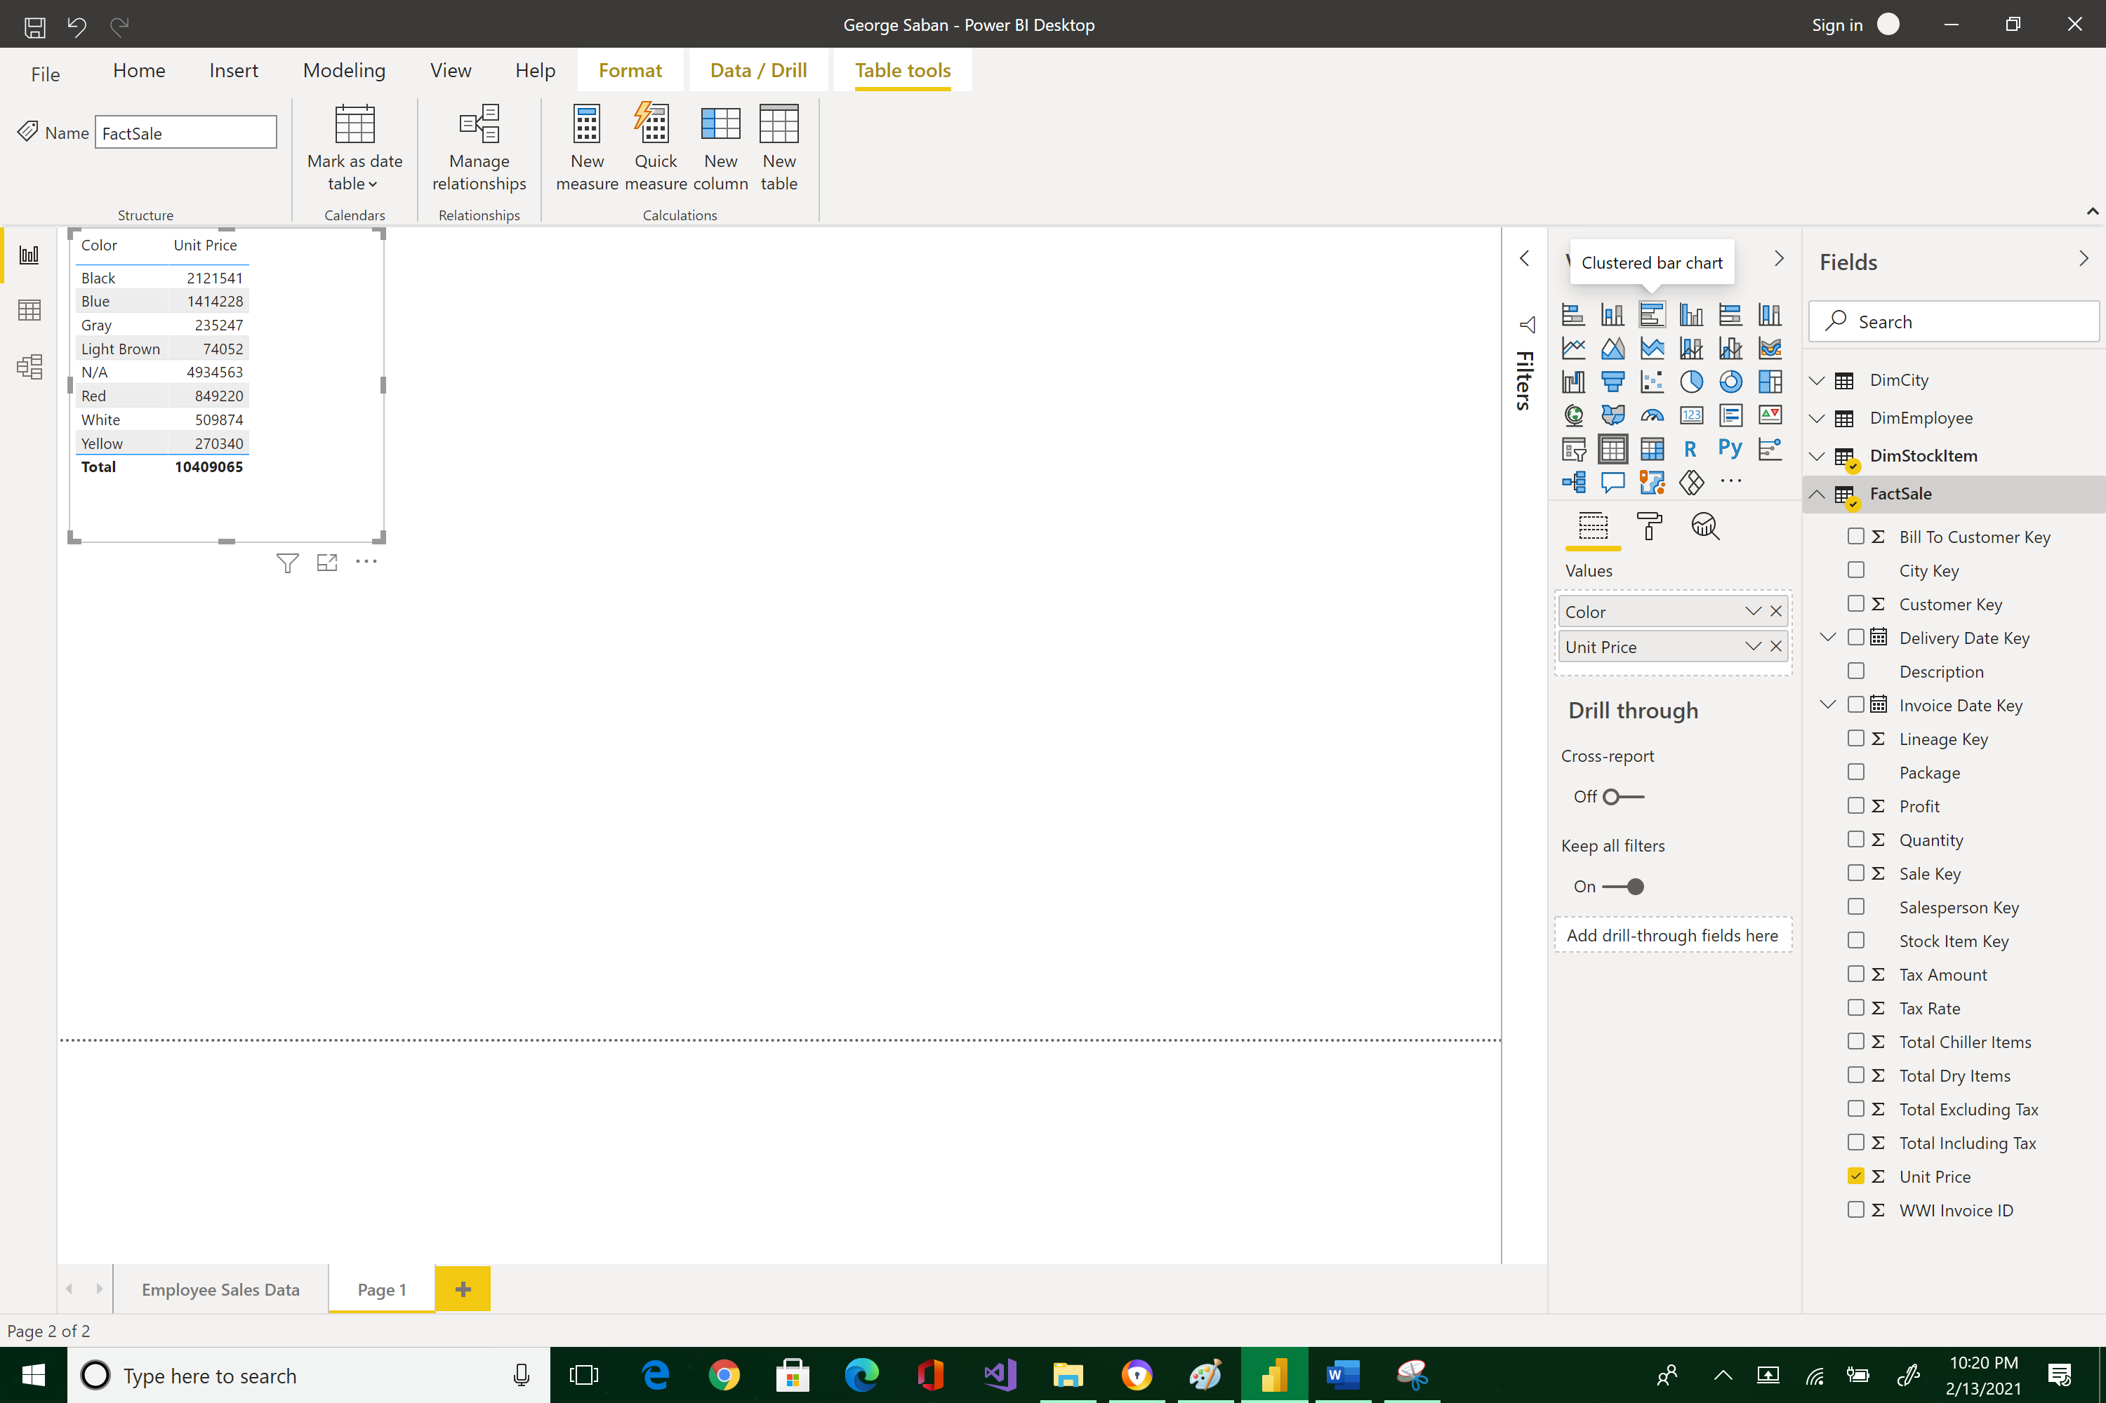



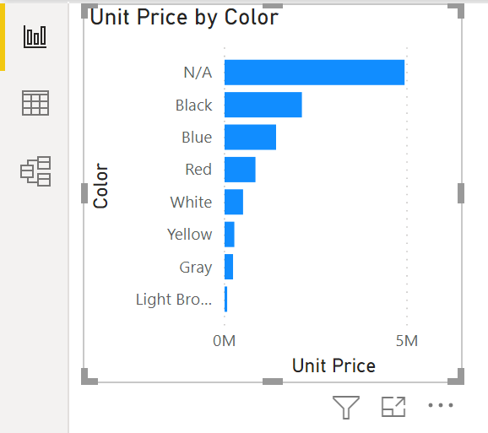

Is there a relationship between color and price? It is hard to tell at the moment because the graph is showing the sum of all the unit prices in unit of millions. This is because Power BI automatically sums numerical fields in a visualization.

Explore more aggregate computations by pressing arrow down next to the Unit Price value and you will see all the other functions. Select Average.

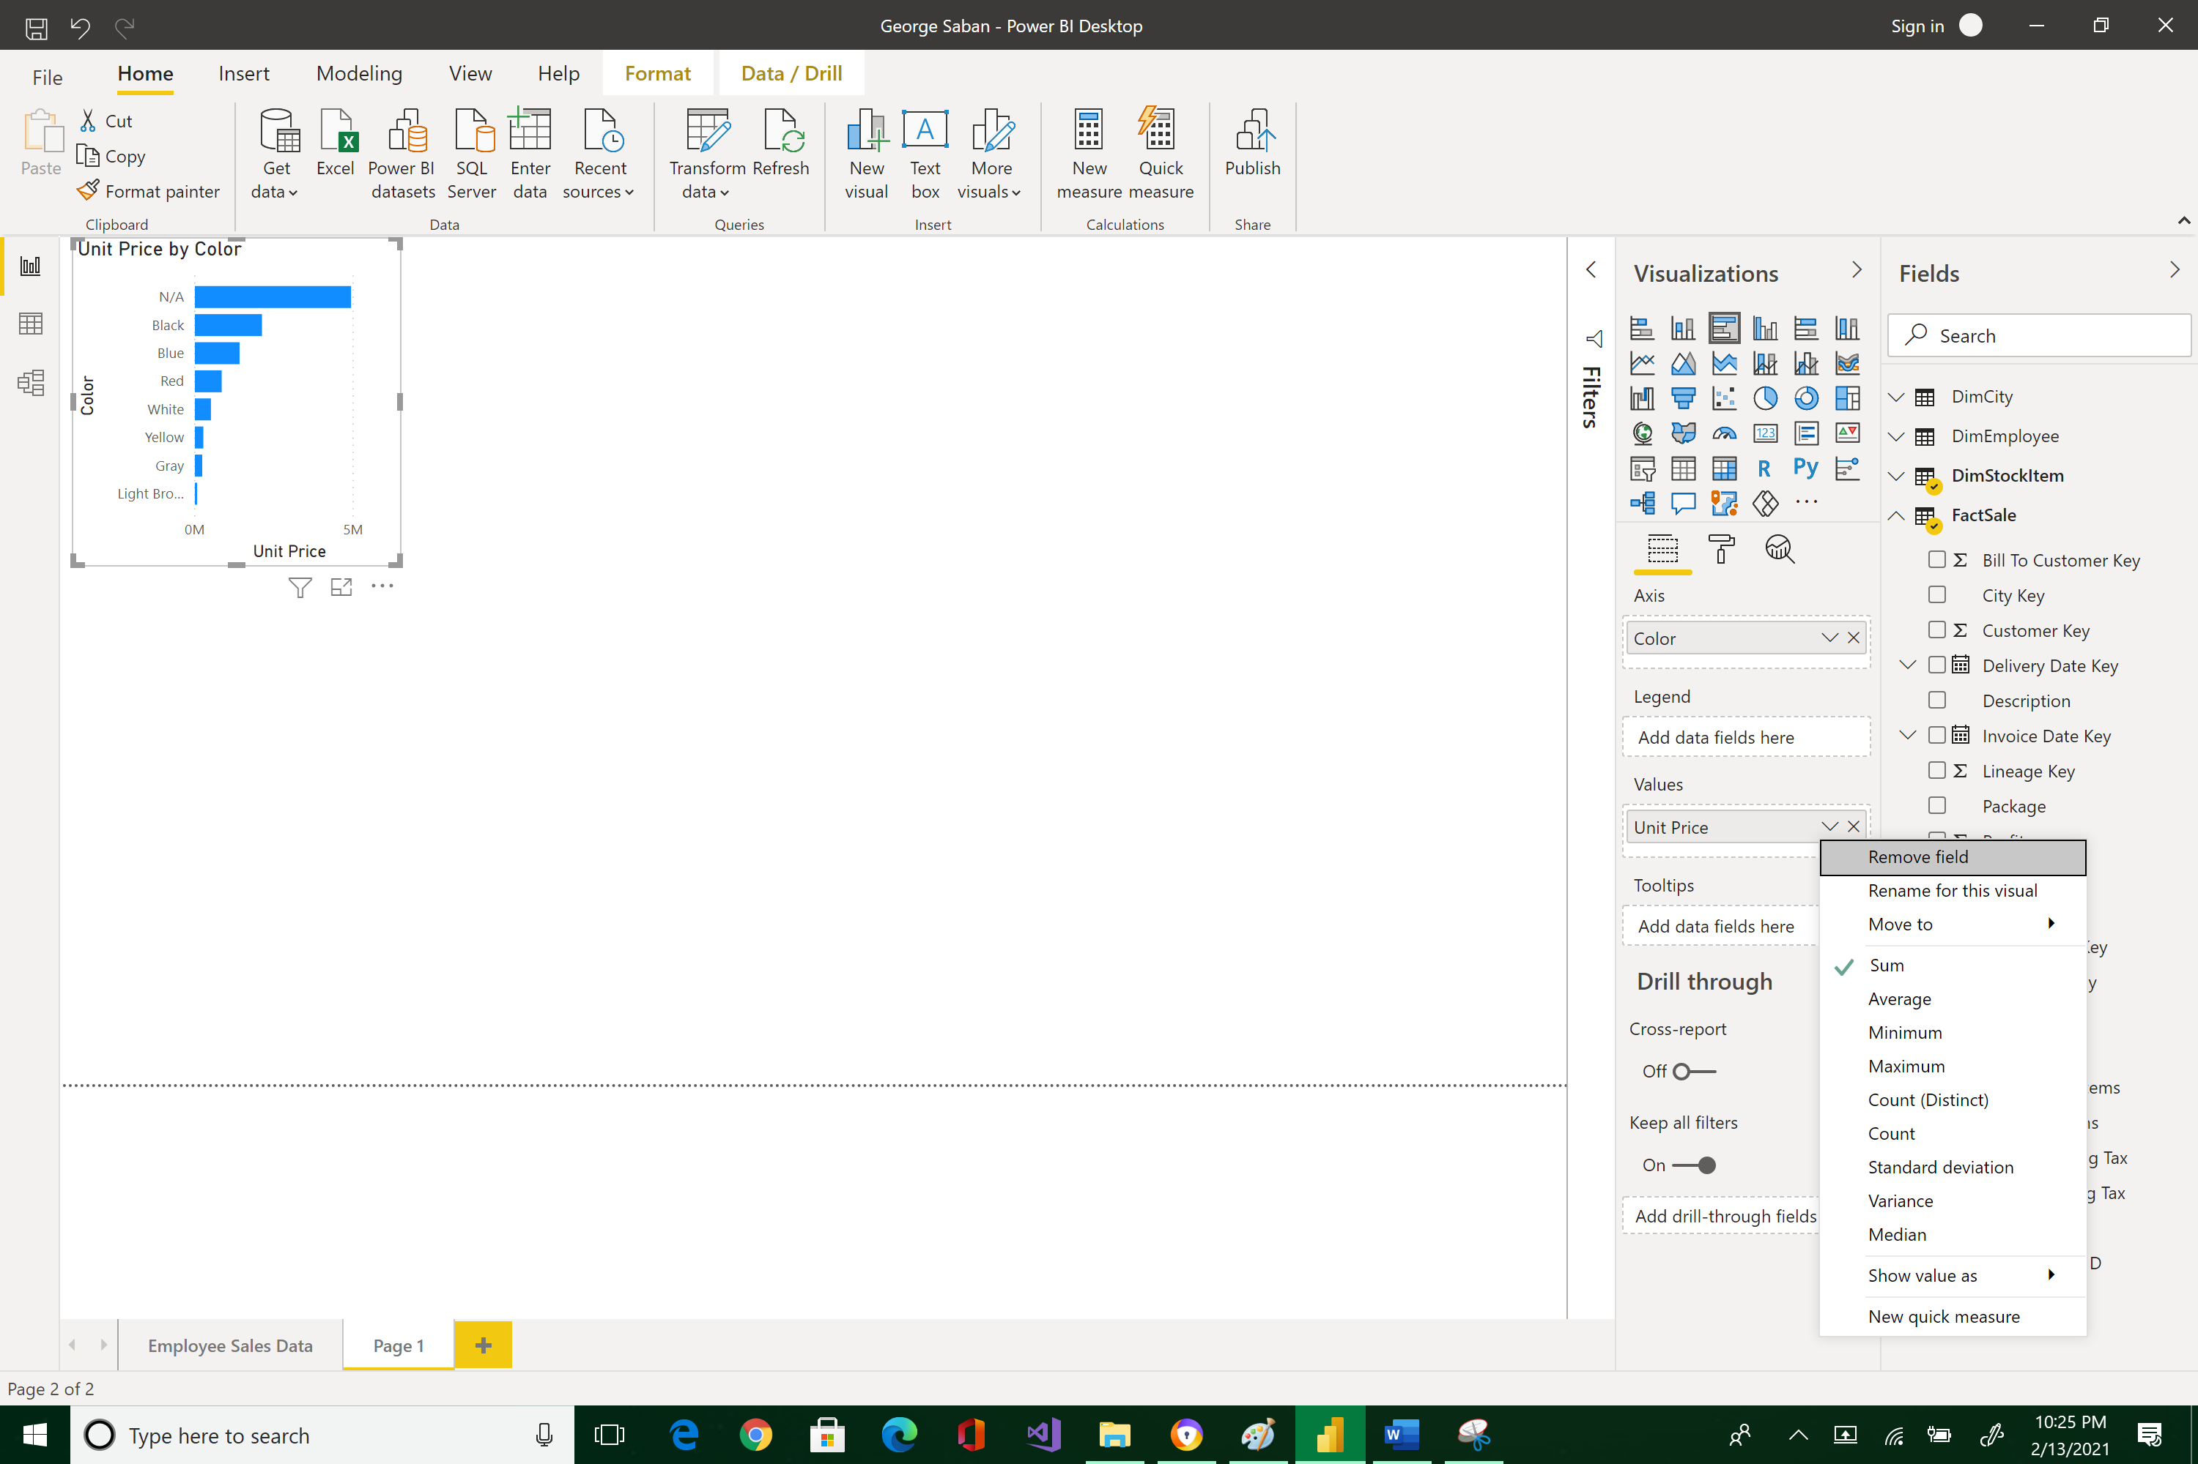



You will see amongst the average calculations that Red items cost the most.

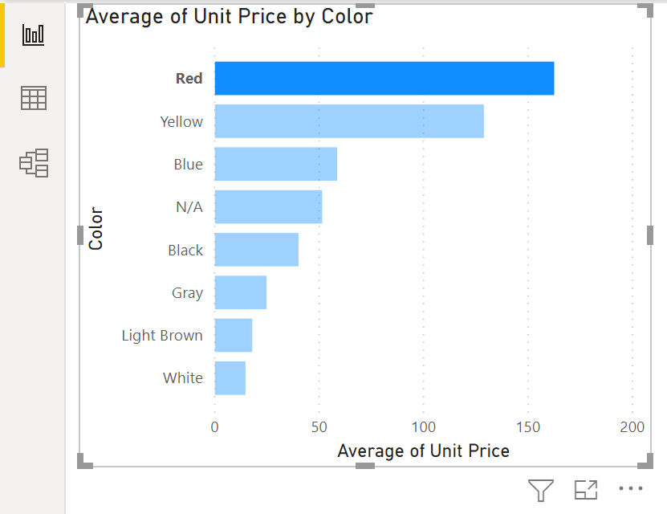

In the first half of the term, we have learned that raw data usually does not arrive in the perfect form when you account for things like human errors, bugs, and file conversion. Power BI accounts for this with the Power Query Editor (this was covered already), which allows you to transform data before loading it to the model.

Now, it is your turn to load another dimension called DimCustomer. This file will need to be edited prior to loading.

* Open the **csv** file DimCustomer.csv from a folder on your local drive.
* Select the Transform Data button.
* Remove the first row. It contains mostly blanks and must be erroneous.
* Make the resulting first row the header row.
* Delete the columns Valid From and Valid To.
* Close and apply.
* In the *Fields* pane, select the *Edit Query* menu option from DimCustomer.
* 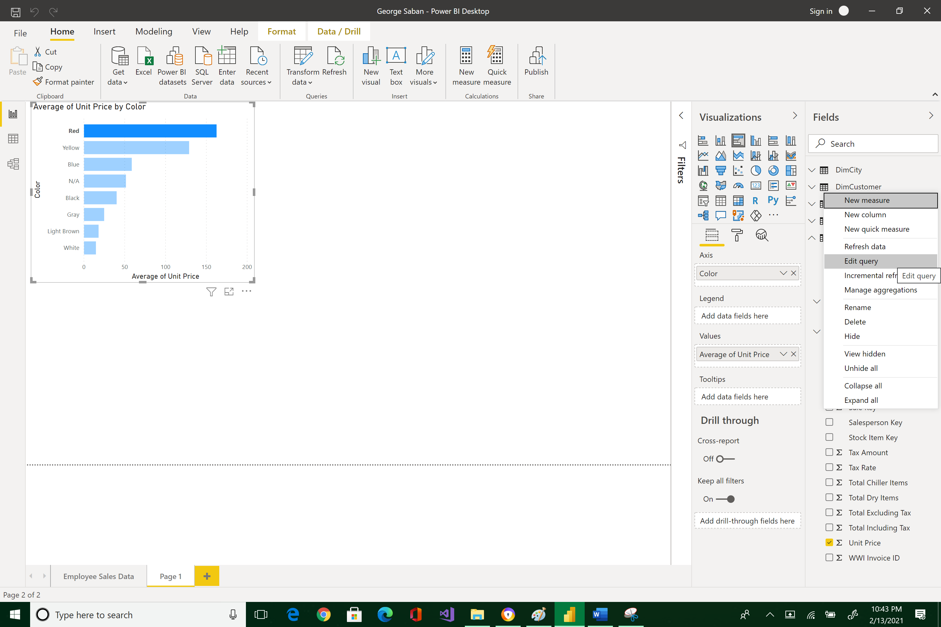



In Power Query Editor window that has opened, how many steps are listed in the "Applied Steps" section?

|  |
| --- |
| 7 |

Please reposition your Report and Data screens so that they would look like the image below. Take a snapshot using Window's Snipping Tool. Make sure the encircled items are included. Place your image at the end of this document (after the example below) and submit this completed document to Canvas in Word format.  Thank you!

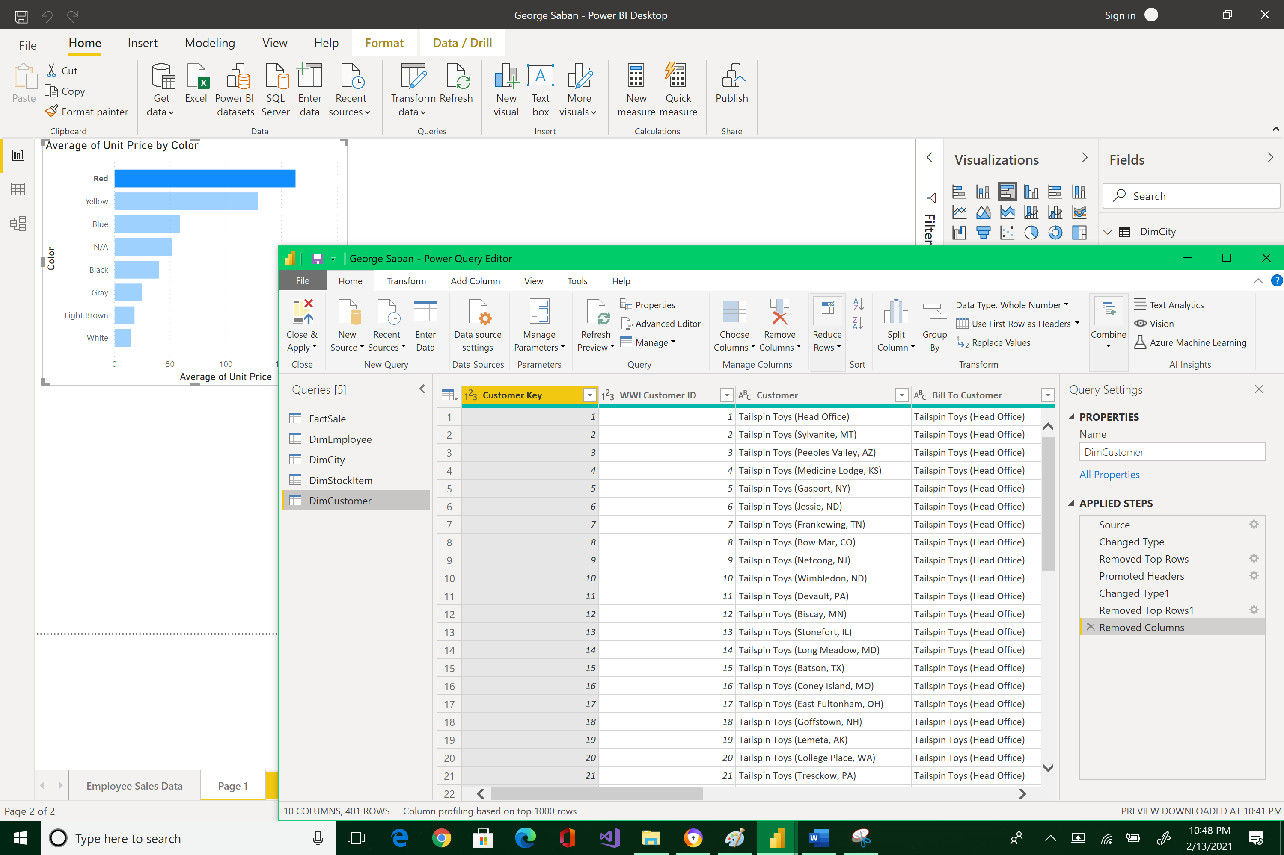



|  |
| --- |
| Please paste here your final image. |